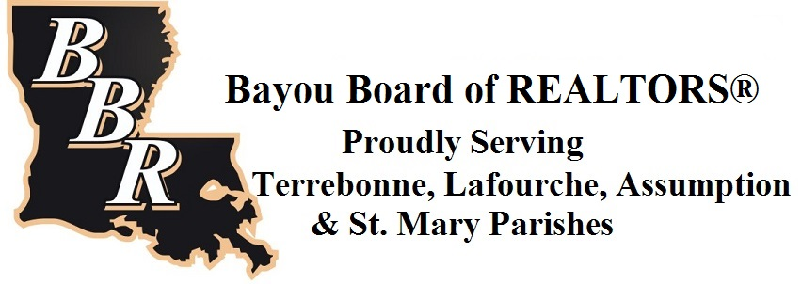
Journey to Careers Grant
PROPOSAL INFORMATION PAGE 2020-2021

PROJECT TITLE:
GRADE LEVEL(S) & OR SUBJECT(S): |  | # OF ANTICIPATED STUDENTS PARTICIPATING:
AMOUNT REQUESTED: | $
YOUR NAME:
YOUR EMAIL:
SCHOOL:
SCHOOL PHONE:
SCHOOL’S PHYSICAL ADDRESS:
PRINCIPAL’S NAME:
LIST OF TEAM MEMBERS (IF APPLICABLE):

DEADLINES:
All components of the Bayou Board of REALTORS Journey to Careers Grant Packet must be completed and
uploaded via the online application at www.tfae.org/grant-information no later than midnight, August 31, 2020.

